
Tom Doolan, Southold Resident And Ex-CEO Of Three-Hospital Consortium On East End, Dies At 90
Staff Writer | 9/2/25
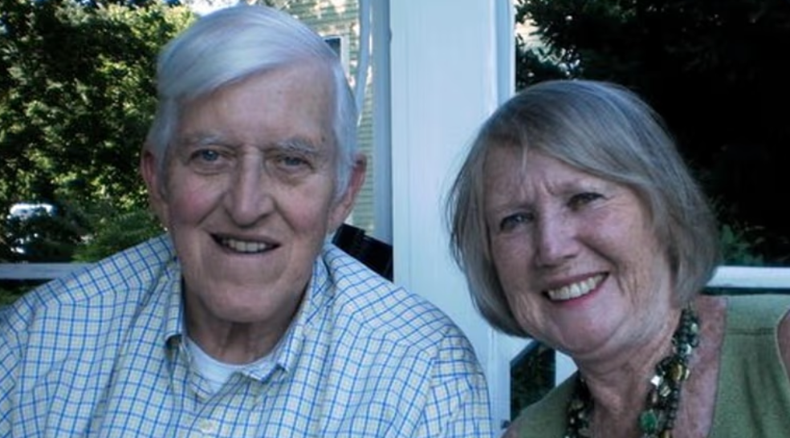
Tom Doolan saved a debt-ridden Southampton Hospital from dying during a career in which he headed at least seven hospitals, operating on inefficiencies and injecting a bit of Irish music by booking world class musicians for concerts, family and friends said.
Best known as chief executive of Peconic Health Corp., a three-hospital consortium on the East End, Doolan was a "stabilizing force" at a time when many hospitals were in trouble, those who knew him said.

But more than a hospital helmsman in his 44 years of work, he was at times a homebuilder, record producer, concert booker, college professor, Ellis Island Medal of Honor recipient, painter, board member at the Peconic Landing retirement community, co-founder of an eating disorder center in Colorado, consultant at family practice centers in California and the phone voice of Cookie Monster to nurses’ children when they refused to go to bed, those who knew him said.

"Tom was a relationship guy," said Paul Connor, chief administrative officer for Stony Brook Eastern Long Island Hospital.

Doolan, who also was an assistant administrator at St. Charles Hospital in Port Jefferson, died Aug. 7 of multiple organ failure. The Southold resident was 90.

Having taken two New Jersey hospitals from debt to profitability, Doolan was a health care business pro by the time he was hired in 1997 as chief executive and president of the Peconic Health Corp., his family said.

He served a double role, acting as the president of the troubled Southampton Hospital only after getting the hospital board’s promise not to file for bankruptcy, saying, "I will not come in and cut people to shreds," recounted his wife, Mary Elizabeth Doolan, of Southold.

"He loved people," said his wife, whom he married in 1961. "Everybody he met, he would find out about who they were, where they came from and what they did."

Doolan convinced the Suffolk County Industrial Development Agency to finance at least $30 million to pay for the hospital’s operations debt and helped set up policies and resource sharing for laboratories, Connor said.

His knack for budgeting stemmed from his Depression-era childhood in the Bronx, the second-oldest of five children, his wife said. He learned to look at prices, she said.

He graduated with a psychology degree from Fordham University in the Bronx in 1958 and began working in the transportation section of W.R. Grace, a global manufacturer and chemical company.

Then the luck of the Irish got him his first hospital job, as director of personnel at St. Catherine’s Hospital in Brooklyn, said his son, Brian Doolan, of St. James.

When the nun interviewing him found out his father was from the Donegal County village where she was born, she hired him with one request — to get his master’s degree in business, the son said: "From that day forward my dad always encouraged his employees to go back to school and continue with their education."

Doolan earned his master’s in business at the City College of New York.

But perhaps what he loved more than the health care business was Irish music. He could easily identify century-old Irish tunes, and learned to play the accordion from John Whelan, hailed as one of the best Irish accordion players.

"It was in his soul," said Irish musician and friend Eamonn O’Rourke. "He organized so many concerts for the musicians to make them money."

Many years, even during retirement, he got more than a dozen metro region hospitals and churches to host concerts of world-class Irish ballad singers, fiddlers and other musicians, including St. Patrick’s Cathedral in Manhattan and hospital staff cafeterias at the Peconic Health Corp., O’Rourke said.

More than five years ago, he fell, damaging his knees; left using a wheelchair, he focused on painting and exhibiting his art, family and friends said.

Doolan saw the "circle of life" playing for him, not just in his return to the hospitals he once led but in the legacy of how he treated others, said O’Rourke, who called the retiree every morning.

"His greatest accomplishment was his son, Brian, and his wife, Betty," the musician said.. "He every day just adored them. ... He would say he’s stuck in the wheelchair and They are so good to me.’ I said, ‘Tom, that’s because you were so good to them from the get-go.’ "

A liturgy of Christian burial was celebrated Aug. 15 at St. Patrick’s Church in Southold, followed by burial at St. Patrick’s Cemetery in Southold.

